

Designed by Antonino Frazzitta

For PC

**Rating**: PEGI 7

**Genre**: Run and gun

# Story

The game takes place in a hypothetical futuristic city; mysterious deadly machines appear across the world and they threaten to destroy it, these machines are the malefic creations of Dr. Boss. Who is going to save the world? We are “Zero”, the only hope for humanity to defeat this menace. For a mysterious reason, we wake up in the middle of the attack and we suddenly know that we need to do something. So we decide to fight them back.

After our first battle, we encounter one of Dr. Boss creations but for some reason, it’s lying on the floor, we won’t speak much with him but thank to him we will understand something interesting, we are not the only ones and that we learn to absorb our similar ability.

Because we want to understand more of us we carry on by discovering more about us and Dr. Boss. By progressing through the areas, we will be able to know a bit more about what surrounds us and our past.

By the end of the game, we will learn something unexpected, we are one of the most powerful creations made by Dr. Boss, but something went wrong. Unfortunately, we have our consciences and feelings and we cannot be controlled. At this point of the story, he will ask if we want to join him and we will refuse as we are the hero of this story.

This secret will be distributed during the gameplay and it will be discovered piece by piece conversing with the bosses.

# Elevator pitch

Mega man meets Castlevania.

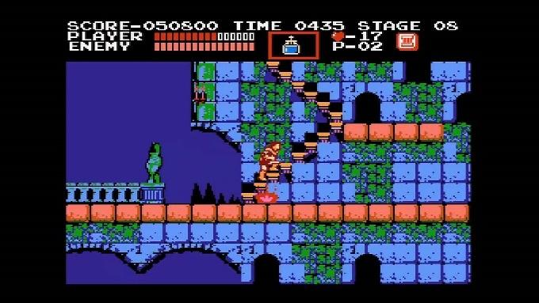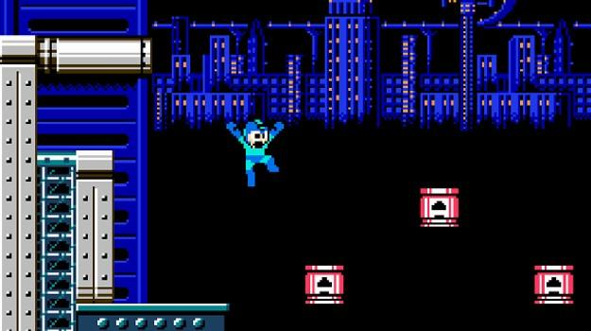

*Castlevania (left) Konami all rights reserved and Mega Man (right) Capcom all rights reserved.

# One-line sales pitch

* **Shoot. Beat. Evolve. :** this one-line sales pitch includes all the main aspects of the videogame. Shoot because this game is a run and gun, so shoot will be one of the main mechanics of this game. The beat is referred to the five bosses which are the rulers of the game world. Evolve is referred to as gameplay as strongly connected to the fact that we have to evolve in order to progress throughout the gameplay. The structure of this pitch is inspired by a political Italian movement that uses something similar which I personally believe is direct and effective. (The *movimento 5 stelle*)



# Target audience

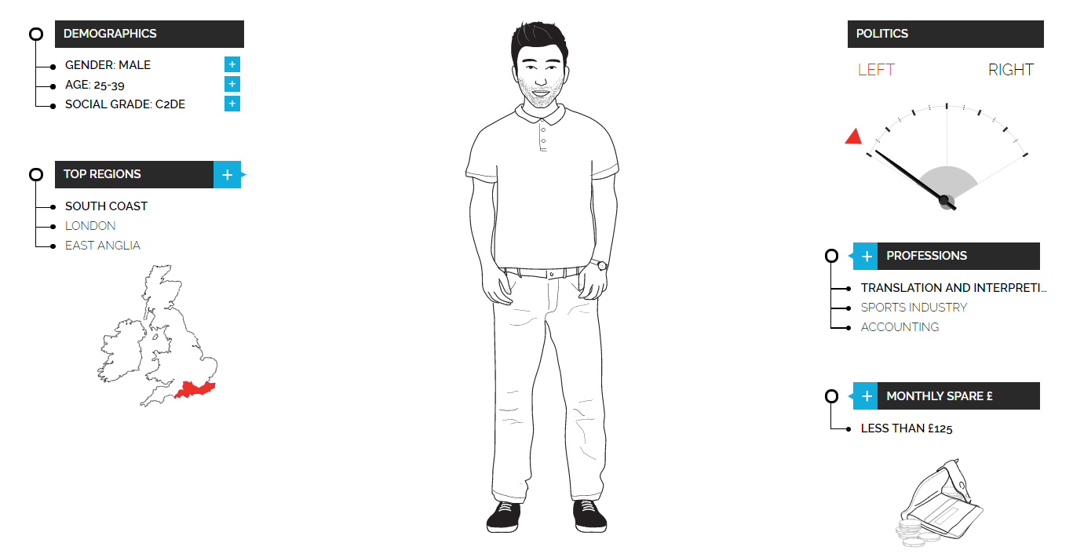

I have done research based on a variety of games and brands that might interest the target audience of this game as they are very similar, and share lots of points in common. For example, I researched what the fans of Nintendo like and above we can see that most gamers share the same type of personality. As a result of this research, I will point to people between 25-39 that lived the “golden age of video games”.

However, I would like to also include this game for a younger audience by designing it for all ages, in order to succeed the theme of the game will be cartoony, the visual style is very colourful, and the game will not contain any type of strong language and the command system will be designed to be easily used from everyone. In this way, I am going to amplify the target audience and add more possible buyers.

# Player Character

* Who is the main character? – “Zero” is a human looking robot able to absorb enemy abilities once defeated, by progressing with the game we will upgrade our gears by giving the player a completely new move set at the end of the game. This will allow the player to play differently the game than how he/she started.

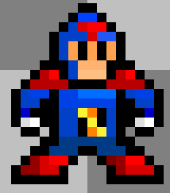



The initial design of the main character.

* **New design:** as I wanted that the main character's results more detailed I decided to improve his design. So, Improved the size of the spite from 16x16 to 32x32, in this way, I could draw more detail. At the moment I have managed to draw the silhouette only.

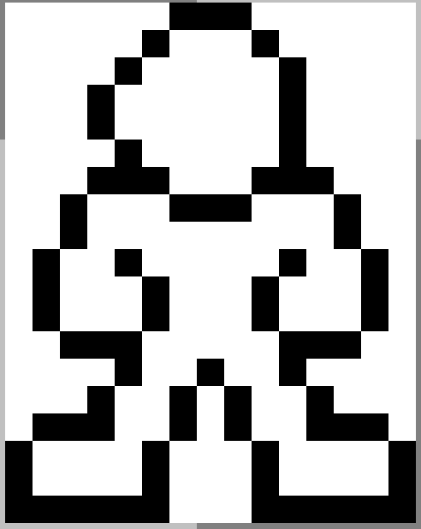

# Abilities

The playing character for the very first time in the gameplay will only be able to shoot but by progressing we will obtain gears from the defeated enemies by absorbing them.

* **Shoot:** shoot is one of the default abilities of our character, when the key is pressed our character will shoot one energy bullet.

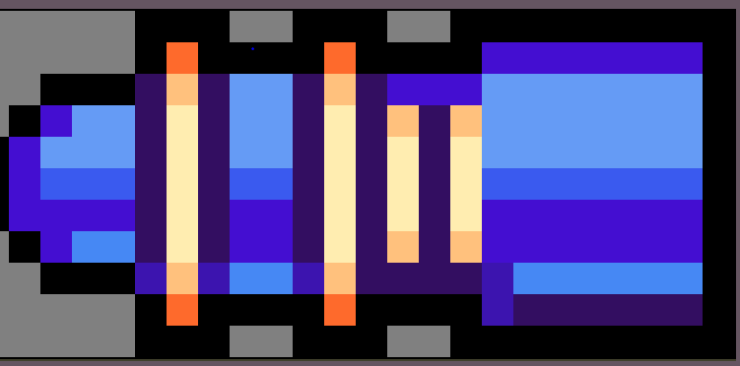

Source HeartBeast Studio: [http://imgur.com/a/ryJ84](https://www.youtube.com/redirect?q=http%3A%2F%2Fimgur.com%2Fa%2FryJ84&v=FpVEUDs4De4&event=video_description&redir_token=l1_G30kmQ9Yt0RLQckeObUHIN998MTUxNjE5NzA2NkAxNTE2MTEwNjY2)

This is the main weapon, the energy blaster.

The blaster will look very similar to this one.

* **Jump:** this is the classic jump; the character will be able to move a few pixels upwards by pressing the key.
* **Dash:** with this ability, our character will be able to slightly dash for a moment.
* **Wall jump:** this ab ability allows the character to use every wall as a foothold to make another jump.
* **Double jump:** with this ability, we will have the same effect as the wall jump but instead of the wall we can re-jump in the air.
* **Charged shoot:** we can use this ability to make our shoot even more powerful for one shoot, we just need to hold and press the shooting button for a few seconds to charge the shoot.
* **Melee attack:** with this ability, we will gain the possibility to use a laser sword that comes straight out from our blaster and perform a close-range but powerful attack.

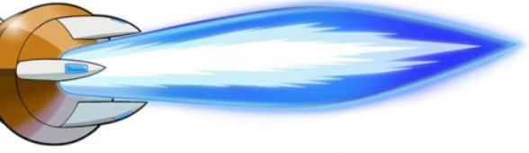

Energy sword used in Megaman battle network Capcom ©.

# Controls and move set

The player will use the keyboard in order to move throughout the level, the character will be controlled WASD as well depending on the preferences of the player, the shooting will be commanded by the spacebar and the various abilities will be called by the keys placed in the middle of the keyboard (from g to ;)

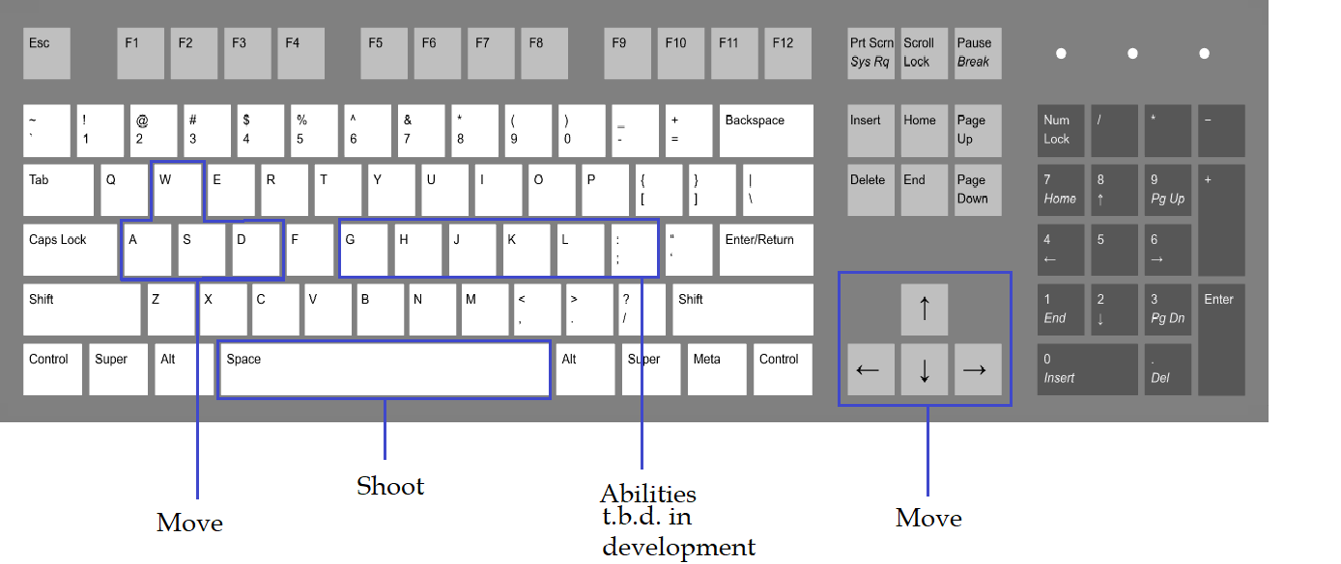

An eventual gamepad adaptation will be designed at the late stage of development.

# Controls flowchart

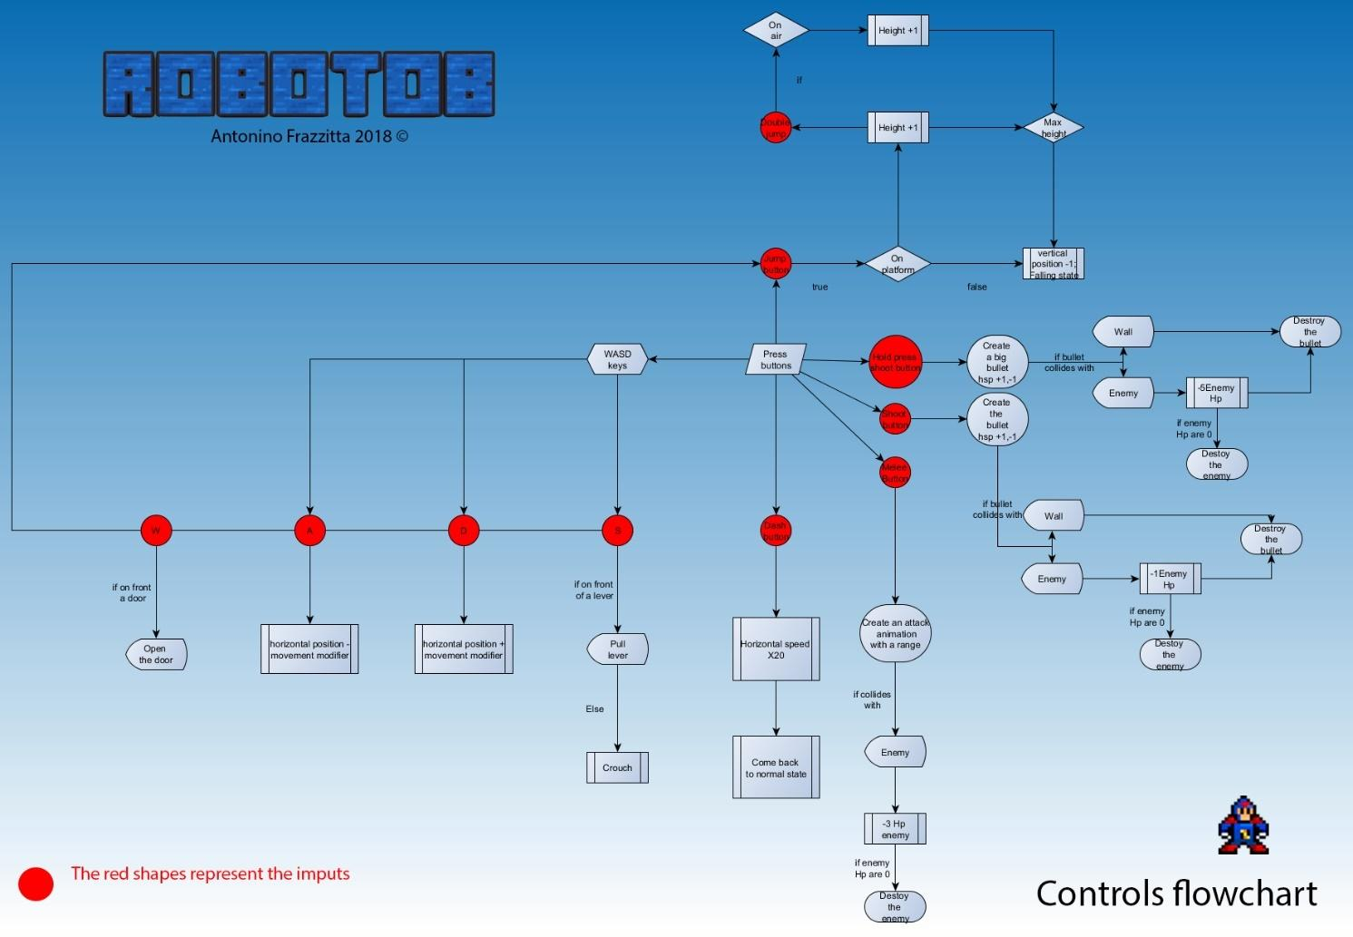

*if you zoom you would be able to see better the label of the flowchart.

# Gameplay

During all gameplay, our avatar will be “Zero” and we will follow his main story in the game. The game is basically a run and gun game with some puzzle elements. We are progressing through the level by shooting enemies, instead of having separate levels the game will have a whole world that the player can explore. The main feature of this game is that when we defeat a boss we can gain his ability, this will allow the character to reach a certain place that before impossible to arrive in order to progress in the game. The player will start the game with only the shooting feature as is the basic ability then we will have abilities like jump and dash.

* **Health system:** our avatar will have an energy system that goes from 100 to 0 when the health meter reaches zero we will lose a life. The variety of the attacks performed by the enemies will subtract a determined quantity of health. For example, a smaller and weaker enemy like Robo-walk will subtract 10 HP as is the weakest of the enemy, instead an enemy like the Robo-boxe will subtract 20 HP as it performs a melee attack and is a more advanced enemy.

The health is indicated by a meter present on the left of the screen. The health bar is inspired by a battery that goes from bright green to red. When we die all the enemy will respawn and we will start slightly backwards.

 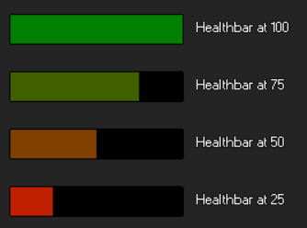

* **Life system:** through the game, the player will have a number of lives, these lives will be collected in the game areas. The lives will indicate how many attempts we have left to finish the level. Every time the HP indicator reaches 0 we will lose a life and if we lose them all we must restart from one of the checkpoints. As well as the health bar, the life counter will be shown in the screen.

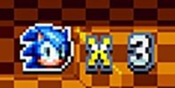

Life icon used in Sonic the Hedgehog, Sega ©.

* **Hitboxes:** The hitbox of the main character has been set in the middle of the sprite as we will have a lot of hazards and stray bullets that will cause damage to the character. Every time an enemy, hazard or bullet will touch this area with his body we will take a damage specific damage depending on the enemy attack.

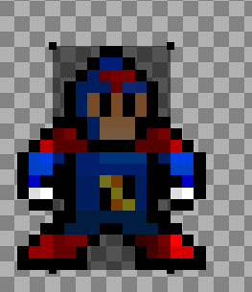

* **Game world**: the game world is made of areas connected with each other that are only reachable by obtaining a certain ability which means defeating the boss of the area.

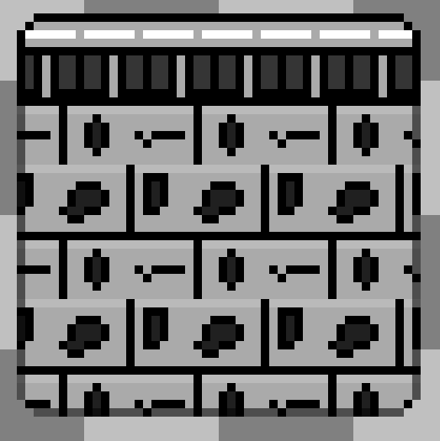

Tile set present in the city area made by myself.

* **Enemies**: Through these areas, we will defeat simple enemies with different properties, for example, the basic one that goes from left to right over and over, the enemy that is able to fly, the enemy that is able to shoot etc.
* **Game experience:** the player will be brought to do sequences of platforming and shooting combined, the feeling will be slightly similar to aMega Man game.

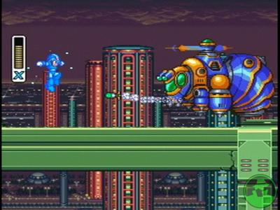

Image taken from [ps2.gamespy.com](https://www.google.co.uk/url?sa=i&rct=j&q=&esrc=s&source=images&cd=&ved=0ahUKEwi5k7_bn9_YAhUqBMAKHc3IAf4QjB0IBg&url=http%3A%2F%2Fps2.gamespy.com%2Fplaystation-2%2Fmega-man-x-collection%2F677298p1.html&psig=AOvVaw32A0BeuL2gccFHxJioI6zw&ust=1516287079840821) (Mega man x)

* **Bosses:** the bosses will represent the area where they belong to the game world and they will possess one main ability that will be highlighted, this ability will be the one that we are going to absorb once the boss is defeated in the form of gears. The bosses will be very similar to us in the look but slightly different.

# Game world

This world is inspired by the futuristic world of Mega Man, and the complexity of castles in Castlevania.

The areas will have something characteristics such as the city, the factory, and the mine. Each area will represent an eventual element; the city is neutral, the factory can be electricity etc. These areas are created to follow and increase the difficulty and progress of the story which will be narrated by dialogues with text boxes.

The mood of the world will be cartoony and colourful, during the gameplay will be accompanied by 8-16 bit music style in line with the pixel art style present in the game. Every area will have a different song in line with the area's mood.

All the world areas are connected to each other since the start of the game but we will not be able to reach them until we learn the right ability that will make us overcome the architectural barrier.

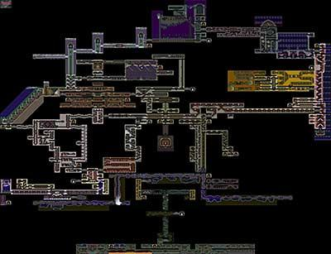

Castlevania (Konami all right reserved) symphony of the night level design(above) and world map(below).

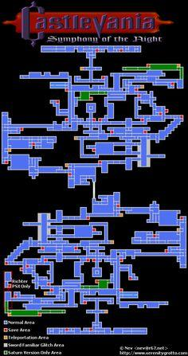

# Areas of inspiration and descriptions

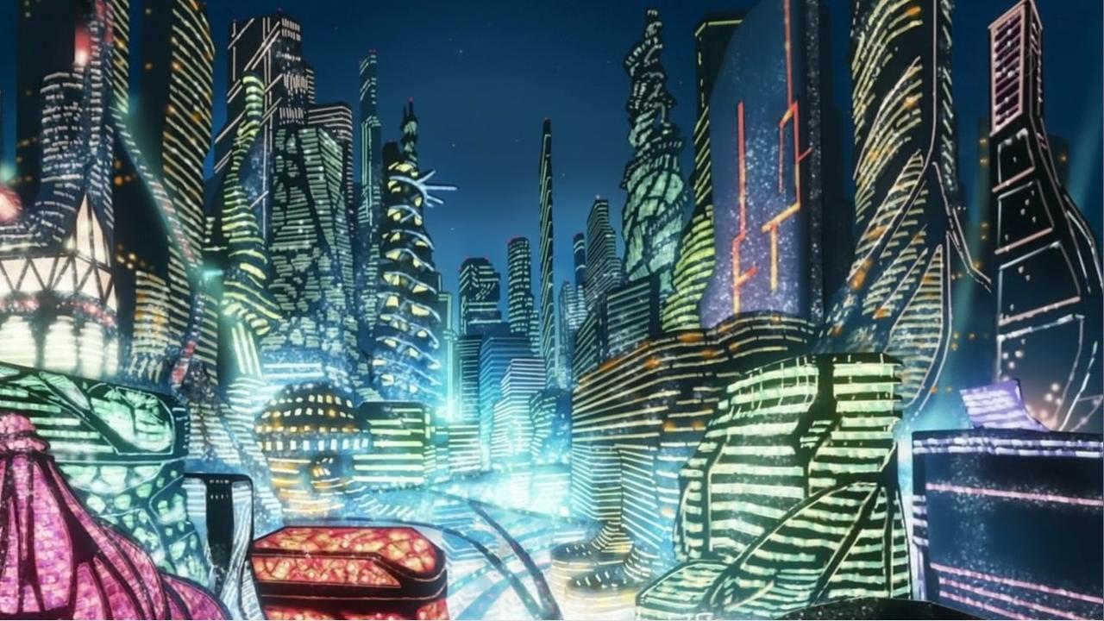

(From: <https://avvesione.files.wordpress.com/2011/03/fractale-07-xanadu-city-lights.jpg> )

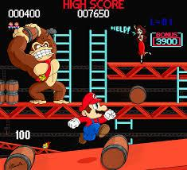

(From: <https://lwiis64.deviantart.com/art/Donkey-Kong-Arcade-189247651> )

* **City:** the city area is inspired by a futuristic city; this is where we start and is the core of the attack made by Dr. Boss. There will be also some areas in construction with scaffoldings, this part of the area will be designed with red scaffolding similar to the donkey king style, here is where we will find Earth-Tron.

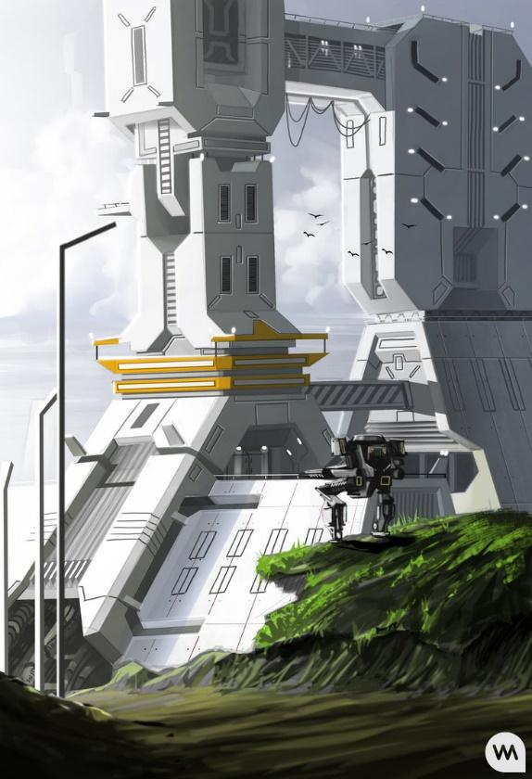

(From: <https://www.deviantart.com/art/Power-Plant-348653487> )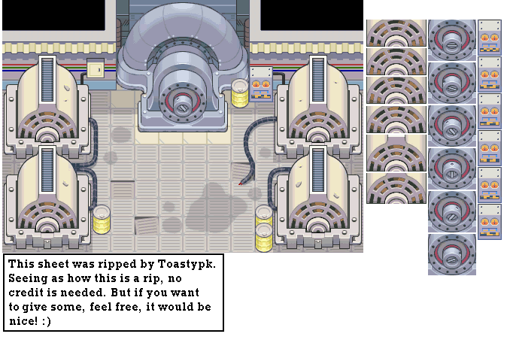

* (From: <https://www.spriters-resource.com/game_boy_advance/pokemonmysterydungeonredrescueteam/sheet/5381/> )
* **Power plant:** this area will be placed into the core of the city and will be the powering heart of it. Its main element is electricity here is where we will find Electro-Tron.

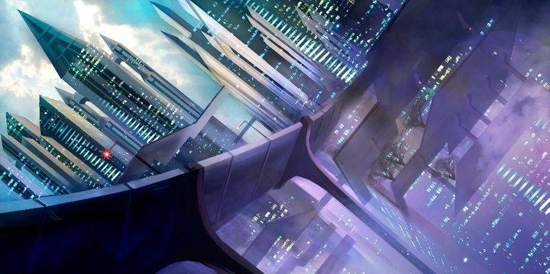

(From deviant art)

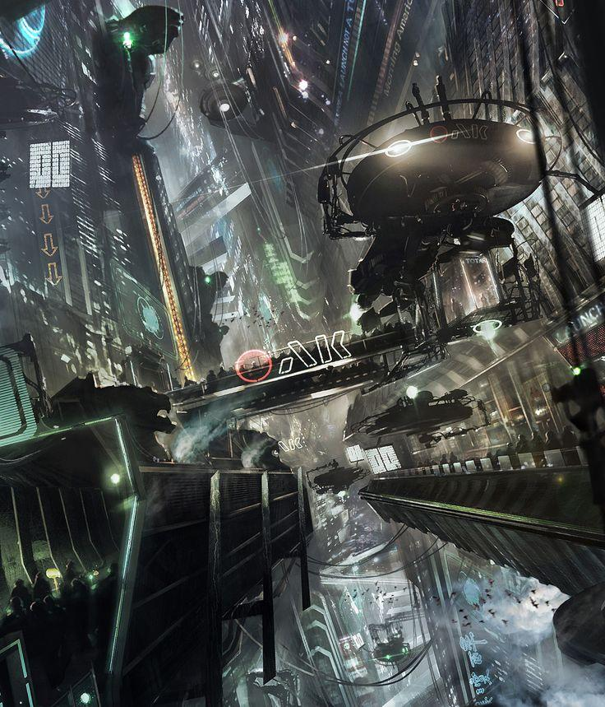

(From: <https://www.pinterest.com/ebructnr/bg-concept-art-layout/> )

* **Higher city:** this is the upper part of the city, here is where we can find Wind-tron, this part will be mainly filled with floating platforms.

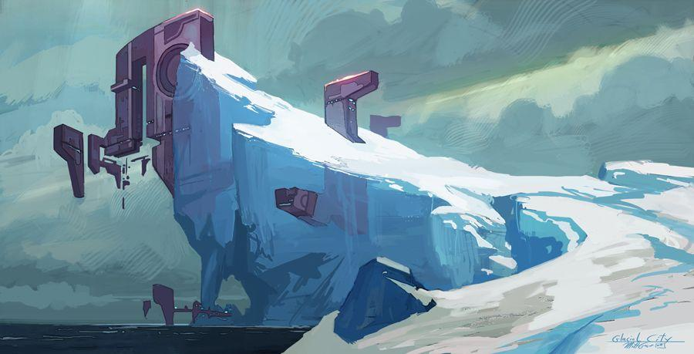

(From: <https://www.pinterest.com/pin/356065914272065895/> )

* **Mountain base:** after the fight with wind-tron we will end up in the mountain base which is slightly away from the city and this area is ruled by Ice-tron.

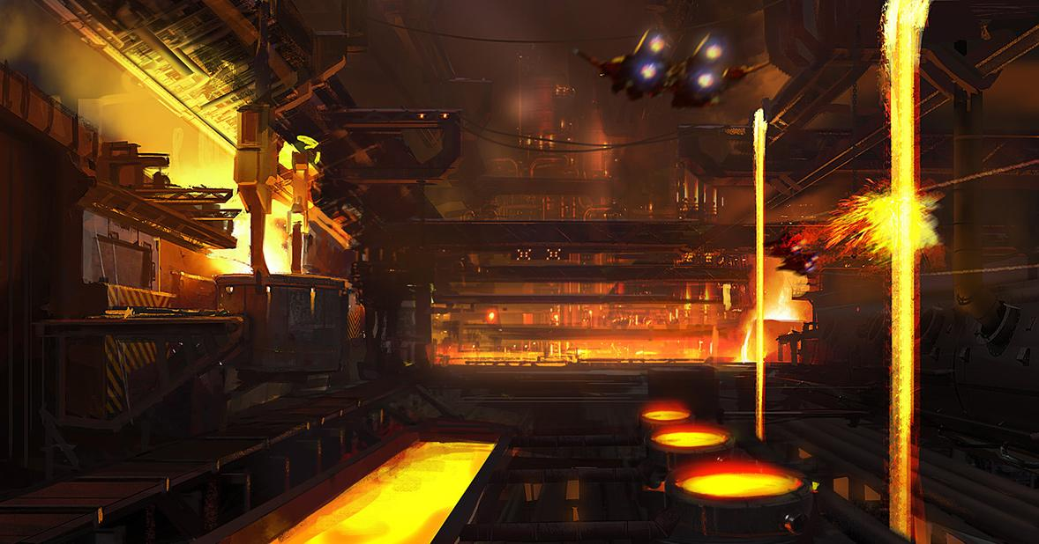

(From: <http://conceptships.blogspot.co.uk/2013/05/concept-ships-and-environments-by.html> )

* **Foundry:** here is where Dr. Boss fabricates his deadly weapons, this place resembles fire and war. Here is where we will find the last of the 5s, Fire-Tron.

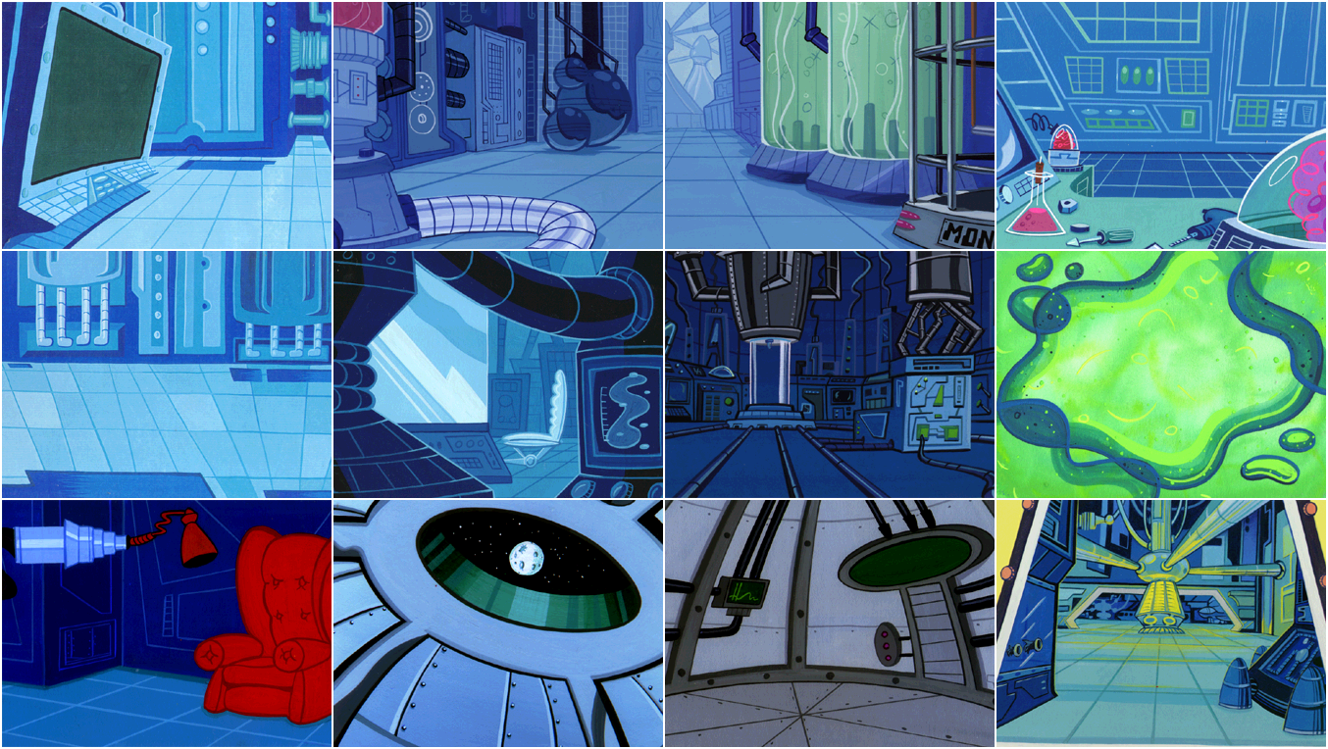

(From: <https://imgur.com/gallery/8zrgn9K>, Dexter’s laboratory)

* **Dr Boss base:** when we finally collect all the five keys from the 5s we will have access to Dr Boss base, here is where we will finally defeat him once and for all! When we unlock the door, we will have access to the final Boss fight which will be divided into three parts.

# Progression in the world

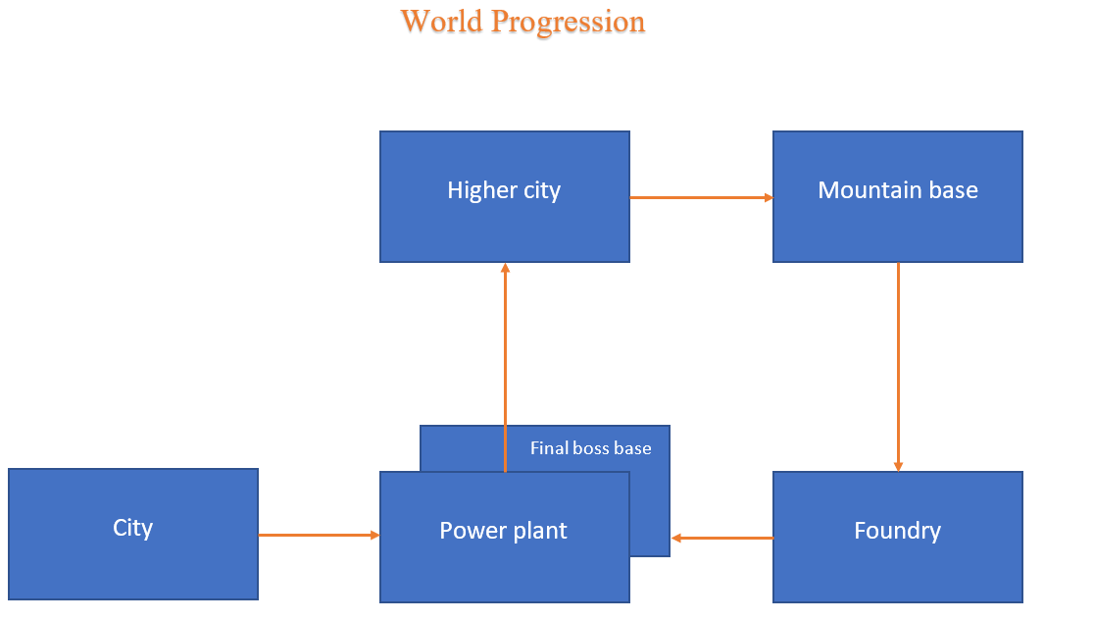

This is a flow chart that represents how we are going to progress through the areas.

# Game experience

The main feeling that I want to transfer to the player throughout the gameplay is the sense of adventure, exploration and growth.

At the very first moment of the game we will wake up in the middle of an attack in the city area, the player will try a few keys in order to understand what are the commands and he/she will realize that we are only able to shoot. After the player realizes what is able to do he/she understands that is aside from scrolling as is only able to go forward. Then the player will encounter simple enemies in order to under understand how to defeat them. After a few enemies, we will meet the remains of a robot like us.

After a few lines of dialogue, the robot will shoot down and it will drop a gear, the first thing that the player will do is go towards the Alpha gear as he/she will be moved by curiosity, as a consequence of that our character will learn a new ability, “the jump”. Thanks to that the player will learn that is able to learn new abilities by taking these gears.

This is one example of the very first moments of the gameplay, as we can see the game is strongly gameplay-driven which means the player will gradually learn from the gameplay experience what is capable of doing and not doing.

During the gameplay will have lots of feedback that enhance the gameplay such as sounds that will improve the sense of defeating an enemy and receiving a new ability, this will play a little characteristic winning music (like we have in The Legend of Zelda when we receive a new item).

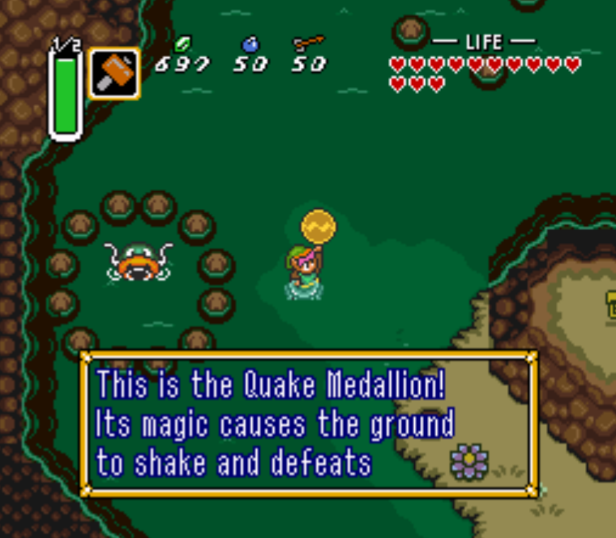

Image provided by [zeldadungeon.net](https://www.zeldadungeon.net/daily-debate-should-old-rarely-appearing-items-return-to-the-series/) from The Legend Of Zelda: a link to the Past (Nintendo all rights reserved)

Some more examples of The Legend of Zelda items receiving animation: <https://www.youtube.com/watch?v=3w-aqAtWAGA>

# Mechanics

* **Platforms**: this will be the main interaction for the players, as the player will be challenged to do some platforming g throughout the gameplay which consists of jumping between them and avoiding an eventual falling. There are different types of platforms:

-**The steady platform**: it’s a basic platform where the player can land and use to progress in the level.

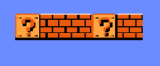 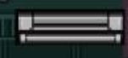

-**The moving platform**: this platform will move by following a determined path in order to set a timed challenge.

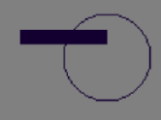 

<https://marketplace.yoyogames.com/assets/1724/moving-platforms>

-**Ice platform** This it’s like a steady platform but it will be slippery because of the ice, this will give extra momentum when the character stops so it will be slightly harder to control the movement.

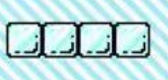

* **Walls:** these are used to stop the player from progressing until we learn “the wall jump” ability, by then the wall can be used to reach new places.

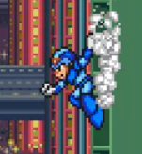

* **Doors and switches**: as well door will be used to lock certain areas, but they will be easily unlocked by standing stitches placed on the floor.

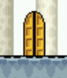 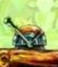

* **Ladders:** ladders will be used for climbing in order to reach upper or downer places.

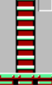

# Hazards

* **The void:** in some places of the game it will be the void instead of terrain, by falling in these places will cause the loss of one life.

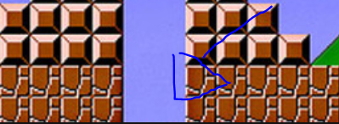

* **Fire platform:** this will turn on and off jets of fire by following a timing.

Electric platform: this will turn on and off an electric shock by following a timing.



* **The tricky platform:** this will open and close following a certain time, and it can cause the player to fall from it.

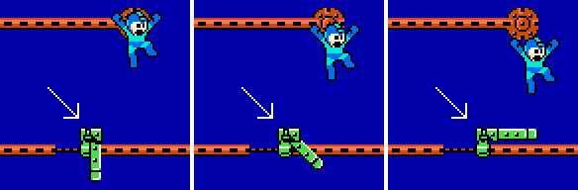

* **Spikes:** spikes are going to be placed on the wall and floor, every contact with it will damage the character's HP.

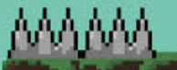

# Power-ups

* **Life up:** when this item will be collected we will be rewarded with an extra life.

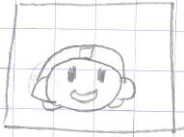

1Up item

* **Energy pack, small:** by collecting this item we will top up a little our health bar.
* **Energy pack, big:** by collecting this item we will top up a lot of our health bar.

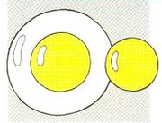

Big and small energy items.

This is an example of how they will look (From the concept art of Megaman).

# Enemies

Enemies are hazards with artificial intelligence. All enemies are beatable by shooting them with our blaster cannon.

* **Robo-walk(shroom)**: this enemy will go back and forward over and over and with collide with them we will lose some energy. This enemy is the most basic and it will be encountered the most. *For this enemy I took inspiration from the **Goomba,** present in Super Mario Bros.

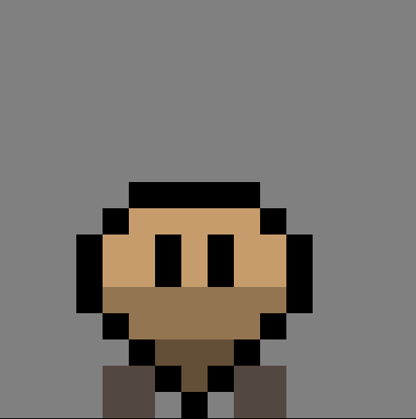 

**Attack: 10**

**HP: 2**

* **Robo-boxe**: this enemy will be triggered if we enter his range which is 96 pixels, once triggered he will follow you until we are far from him a minimum of 128 pixels. Once we collide with it or we will be attacked we will have an energy loss. * As I wanted to keep the same style as the previous one, I copied the shape and I tried different possibilities, it reminds of a boxer as his main ability is a melee attack with his punches.

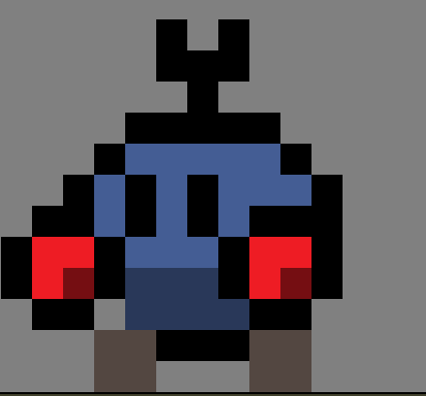

**Attack: 20**

**HP: 10**

* **Robo-bat**: it will fly and follow the player until it collides with the player, if it hits you will lose some health. *For this enemy I took inspiration from the bats present in Castlevania

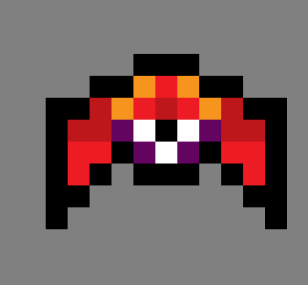 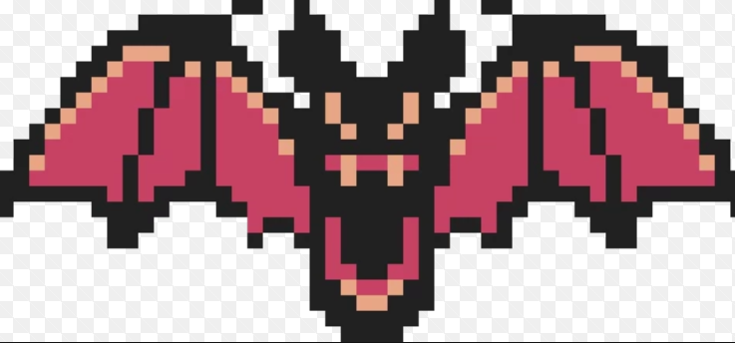

**Attack: 10**

**HP: 2**

* **Robo-blast**: This enemy will shoot little energy balls that can cause an amount of damage to the player. In order to avoid the enemy it will jump a little backwards when we are too close * This enemy was inspired by Kirby, a Nintendo character.

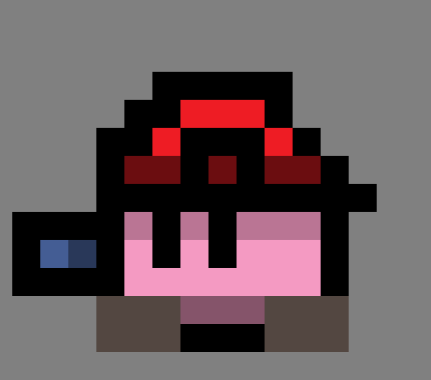 

**Attack: 15**

**HP: 5**

* **Robo-eye:** this enemy is a turret that will be triggered when we are close, this turret is designed to supervise and protect important areas within the game. It will shoot but it’s not able to move. * For this one I tried to give it some personality, therefore I made it with an eye. It is slightly inspired by a duck because of its shape.

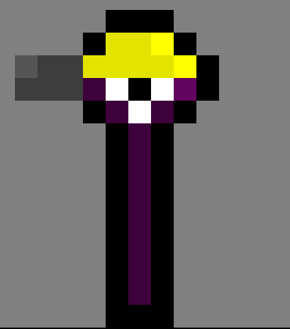

**Attack: 15**

**HP: 5**

* **Robo-spike:** this enemy will float in the air by going up and down in order to make a timed obstacle for the player. This enemy is more a hazard rather than a living enemy but I still wanted to give a personality to it in order to stay along with the game style.



**Attack: 25**

**HP: 20**

* **Robo-rocket:** this enemy is a moving one that comes from the right to the left of the screen and it will try to collide with the player, it can only go in one direction. It can be avoided or destroyed.

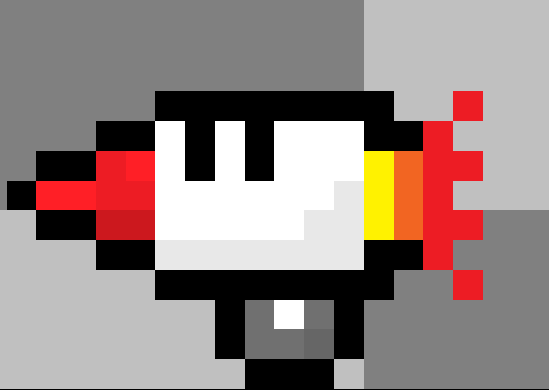

**Attack: 25**

**HP: 2**

* **Robo-Tank**: it will be slightly more resistant and bigger, but it can be easily eliminated with one charged shoot.

**Attack: 30**

**HP: 20**

* **Robo-ninja**: it will jump over the screen by using a random pattern and use its sword to perform a melee attack which can be considerable damage. As they are very fast with their movement a melee attack would be an easier approach.

* This enemy is inspired form of the ninjas present in video games.

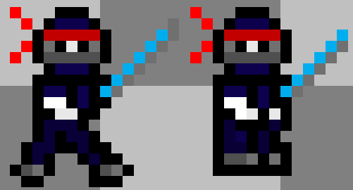

(The right sprite will be used when it gets a hit)

**Attack: 20**

**HP: 5**

* **Robo-spy:** this enemy is a little moving turret that can shoot; it can cause a little damage. His main ability is that he can climb different surfaces like a wall or the ceiling.

**\***This enemy is inspired by the Symmetra’s turret present in Overwatch. 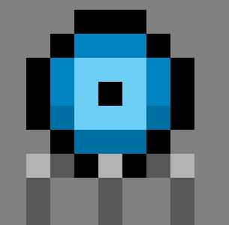 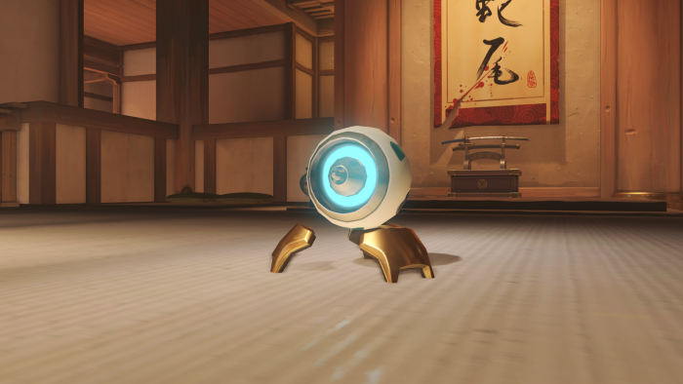

**Attack: 10**

**HP: 1**

# Finite state machine – enemies

Different states: attack, pushed away, normal state, follow state;

Alternate states: attack, pushed away, follow state;

* example of attack state:

**If** { player is next switch **attack state**

}

**While** { play the attack animation

}

**Then** { if animation collides subtract N Hp

}

**Else** { stay in the **normal state**

}

* example of pushed away:

**If** { collision with player bullet take place

}

**while** { create a horizontal speed push = opposite direction of the bullet direction

}

**Then** { come back to the **normal state** after the push

}

* example of normal state:

**if** { object exist keep run the code under the **normal state** (e.g. stay still, move back and forth, wait for player that enter in a determined range etc. )

}

**Else** { switch to the other states if conditions under **alternate states** are met

}

* example of follow state:

**if** { player enters into a determined range (e.g. 28px,52px area)

}

**Then** { follow the player

}

**If** { enemy exit out of the range

}

**Then** { go back to the **normal state**

}

**Else** { stay in the **normal state**

}

# Bosses, the 5s

Some of the attacks done by the bosses are elemental which can cause an altered state for a set time.

* **Spark-Tron**: this boss can be found in the factory, its main attacks its electroshock and thunders generated by him. He will be able to dash in order to avoid you. Once defeated we will obtain the Beta gear that will make us able to dash.

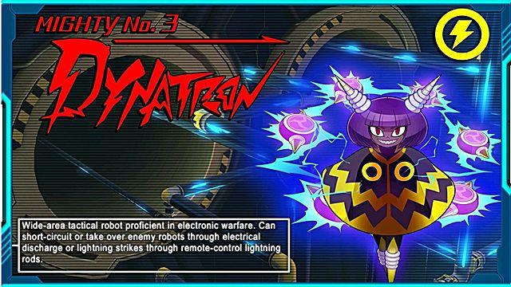

This is how the electricity boss will look roughly like. From mighty no. 9

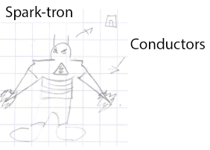

**Attack: 25**

**Chance to get paralyzed**

* **Frost-tron**: this boss can be found in the mountain area; its main attacks are ice cubes and ice jets. He will be able to wall jump in order to avoid you. Once defeated we will obtain the Omega gear that will make us able to wall jump.



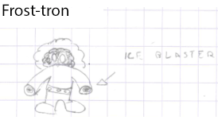

**Attack: 25**

**Chance to freeze**

This is one example of how the ice boss will be designed. From <http://pixelartmaker.com/art/7a692f95371e8be>

* **Wind-tron**: this boss can be found in the Upper town; its main attacks are air blades and tornadoes that will push you away. He will be able to double jump in order to avoid you. Once defeated we will obtain the Gamma gear that will make us able to double jump. This boss is also the captain of the Robo-bats.

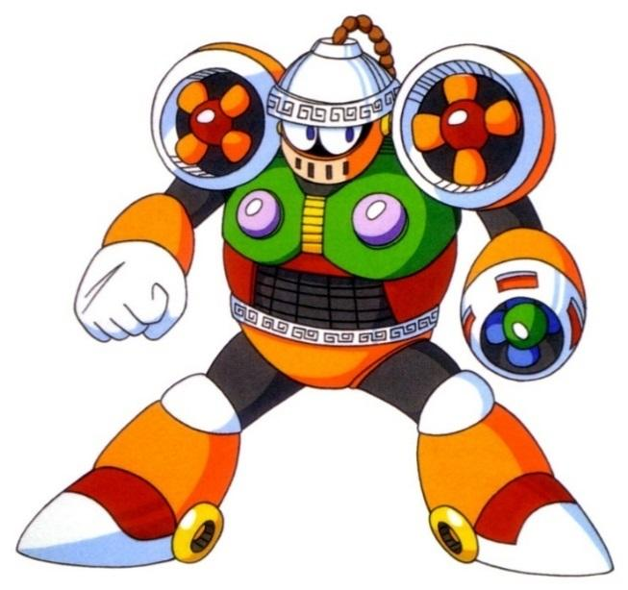

One example of how the wind boss could be. From Mega Man 6.

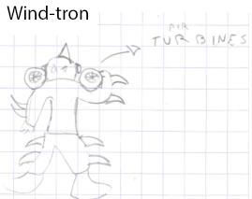

**Attack: 20**

**Chance to blow away from the stage**

* **Earth-tron**: this will be the captain of the tanks we can find him the work in progress area, its main attack is throwing blocks and earthquakes that can cause the falling of some scaffolding (and some energy power-up). He will also be able to do a charged shoot that will take a considerable amount of health. Once defeated we will obtain the Sigma gear that will make us able to do the charged shoot.

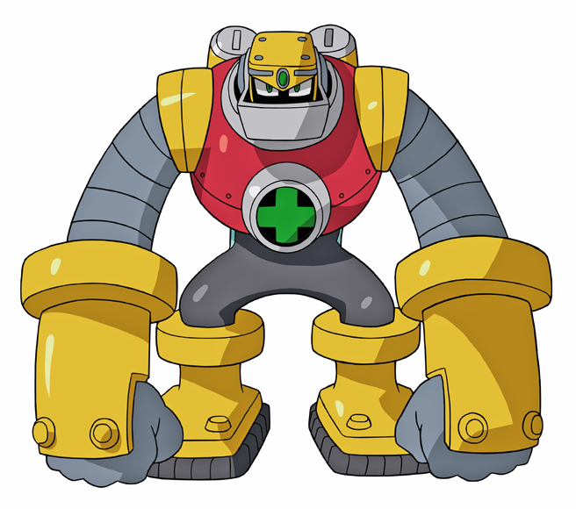

This is how the earth boss will be inspired. From Mega Man: battle network.

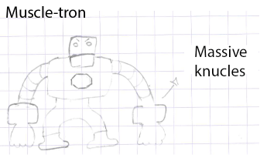

**Attack 30;**

**Chace to get you stuck on the floor**

* **Fire-tron**: this boss can be found in the foundry area; its main attacks are fireball and fire jet. He can also swing a fire sword which is quite deadly! Once defeated we will obtain the Omega gear that will make us able to swing the fire sword.

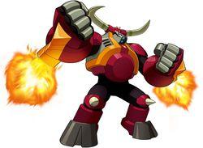

Example of the fire boss, concept art taken from Mega Man: Star Force.

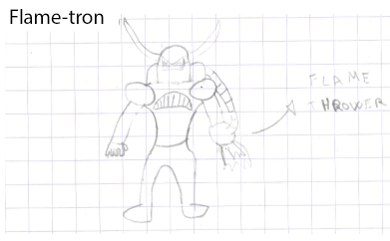

**Attack: 30**

**Chance to be set on fire**

# Final boss

The final boss the evilest of them all none other than Dr. Boss. To unlock this fight, we must have all the gears, these gears will unlock the door of his laboratory.

This battle will consist of three different phases that require us to master all the abilities that we learnt. Every phase will be depicted as one of his three energy bars. When we manage to subtract an energy bar. We will step into the new phase of the battle; the changing of the phase will affect the difficulty and the change of the scenario. When we finish the phrase, a dialogue will start and subsequently an ending cutscene.

* **First phase:** in this phase, we are still inside Dr. Boss base, the difficulty it’s easy. The fight will take place on a rocket platform.
* **Second phase:** in this phase, Dr. Boss goes mad and he decides to launch the rocket with us. So, this battle will take place between the stratosphere and the mesosphere.

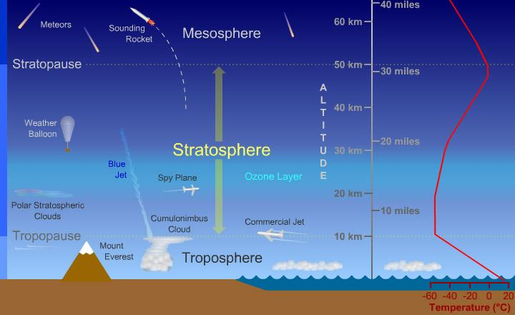

* **Third phase:** in this phase, the rocket gets damaged, so as a consequence, we will free fall back to the earth. This is the hardest of the phases

Once we finally beat him we understand that we are also one of his creations, the most powerful of them all. At this point, we can decide if join or stop him.

# Dr. Boss background

Dr. Boss has a headquarter placed in the city, before the attack it used to be one normal building like the other, but Dr. Boss took over it and decided to use it for his evil plans. Nobody knew him before the attack. One day for some reason he decides that he wants all the world for himself and he sent his tropes everywhere.

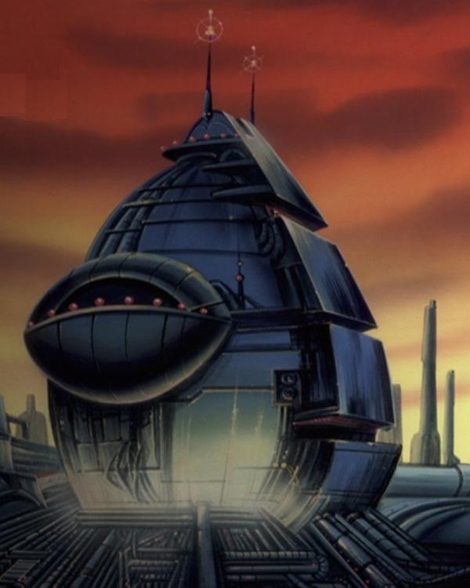

(From: <http://evil.wikia.com/wiki/Robotnik%27s_Headquarters> )

This base is inspired by the Dr. Robotnic base (Sonic the Hedgehog, Sega ©).

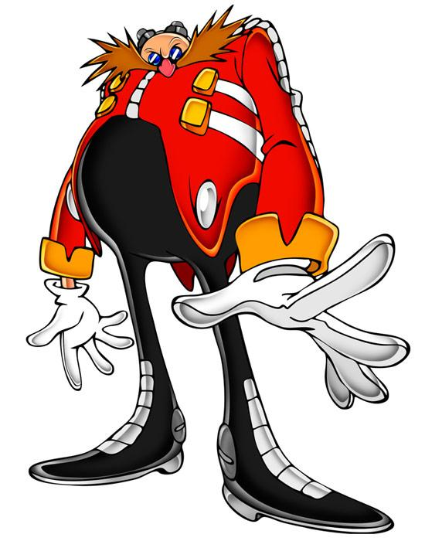

He is an eccentric crazy evil scientist that has only one objective on his mind conquest of the entire world, no one knows why maybe his parents didn’t love him or he was just bored! As well as the tower this character is inspired by Doctor Eggman because of his personality and cartoony shape.

# Cutscenes and narration

All the cut scenes will be made with the game engine by the use of in-game assets, also the opening intro. There won’t be many cutscenes, the main narration will be exposed to the player by text boxes through the dialogue between the main character and the bosses.

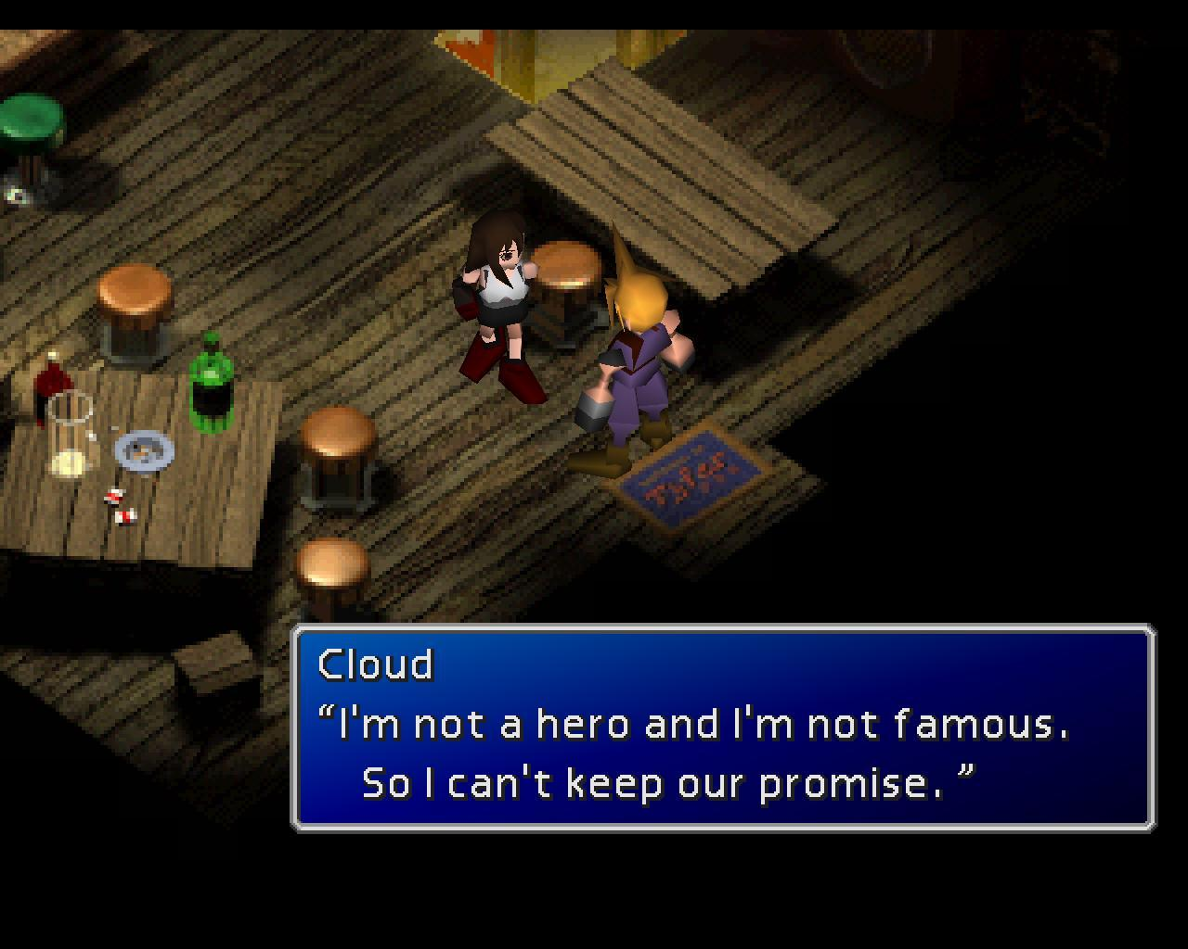

Screenshot from Final Fantasy 7, Square Enix ©

# Possible ideas- cutscenes

It will be the presentation cutscene that will represent the world and what happened before the gameplay.

There will be also a closing cutscene that will be shown depending on what path we chose when we defeated Dr. Boss

# Intro scene – Storyboard

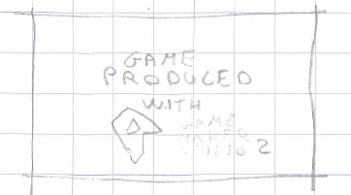 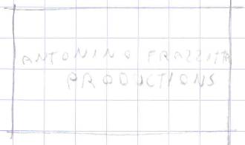

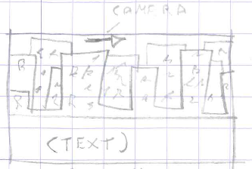

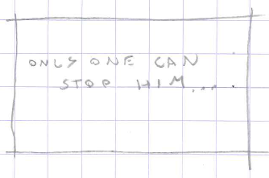 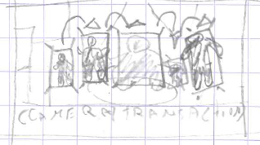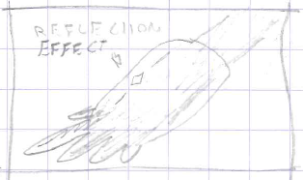 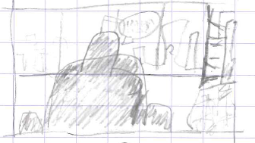

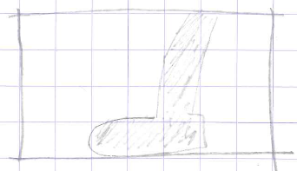 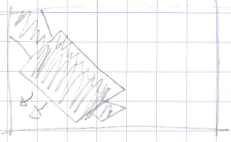

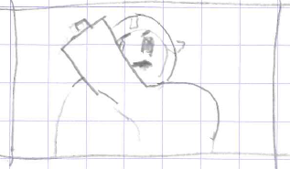 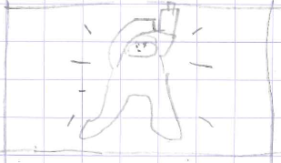

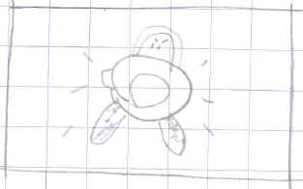 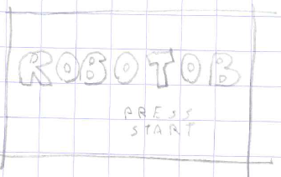

# Music and SFX

The music will be designed to follow the retro visual style, this is why I have chosen 16-bit music as it’s easier and it goes along pretty well with the pixelated art style.

To achieve this, I will use Bfxr, a dedicated website that allows me to create sound effects in a retro style. In this way, we can create effects for things such as jumps by using samples and modifying their properties.

<https://www.bfxr.net/>

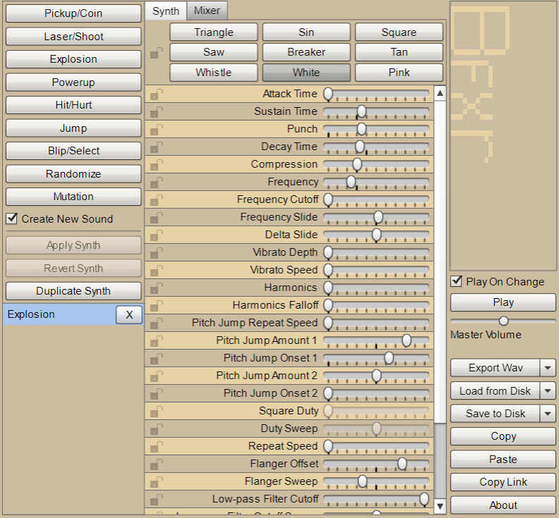

For the music, I will use a tool called BeepBox which is a free website where you can compose this type of music by simply filling boxes that are played in a loop.

<https://www.beepbox.co/#5n31s0kbl00e03t7m0a7g0fj7i0r1w1111f0000d1111c0000h0000v0000o3210b4h4h4h4h4h4h4h4h4h4h4h4h4h4h4h4h4h4h4h4h4h4p16000000>

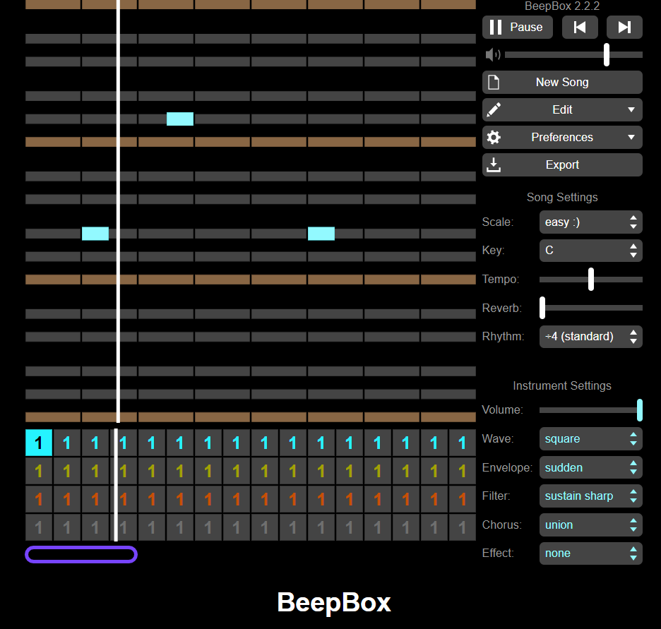

# Extra content

This will be released if I will have spare time to develop extra content after the game production. This will include:

* A secret boss
* A secret ability
* An Armor that changes by showing the progress of the player
* Customisable skins
* More cutscenes
* A mini robot that will follow and help you for a certain amount of time

# Eventual sequel

This might be developed if the first game will have any success, it will have new allies, and new bosses with combined elements such as earth and electric will create an iron element that can create the ability to throw saws or ninja stars.

I might also add the possibility to play different characters in the future and so on…

Background source: <http://knowyourmeme.com/photos/970154-pixel-art>